FTPCapture Engine Plugin Usage

This document describes the FTPCapture engine plugin, its purpose, installation, and usage.

Introduction
The FTPCapture plugin is one member of the WildPackets Lawful Intercept Support Package (LISP) bundle. This suite of analysis modules provides powerful tools in support of lawful intercept and targeted packet capture. In the case of the FTPCapture plugin relevant FTP packets are filtered from the network according to various criteria configured by the user. The resulting packet display reflects only those packets which meet the selected criteria. The design of this, as with other LISP plugins, allows user configuration to align with different legal constraints on the capture such as displaying or not displaying a user name and so on.

Ftp (File Transfer Protocol) is a protocol for transmitting files across the network. The particulars of ftp usage are assumed to be understood by the reader of this document and will not be presented herein.

The file name for the FTPCapture plugin is FTPCapture.dll. It is accompanied by the config file FTPCapture.he.

Console and Engine Versions of FTPCapture
FTPCapture plugin versions are available to run on both the OmniPeek and OmniEngine platforms. The two plugin versions are referred to as the console (OmniPeek) version and the engine (OmniEngine) version. The two versions have analogous behavior and results. Both are dll files. Both are filter type plugins (see below) whose results show in the packet display screen of OmniPeek. Both have an identical options setting dialog* as well as About box.
*A new tab has been added to the engine plugin as a compile option. This “New Functionality” and a new options tab that goes with it will be described in a section later in the document.

5

Although both the console and engine versions of FTPCapture come as a single dll, the engine plugin dll is actually installed on both on the OmniEngine computer and also on any OmniPeek computer that will be accessing FTPCapture on the engine. This OmniPeek install is required in order to create the required analysis module filter as well as to set user options via a dialog window.

This document describes usage of the engine plugin.

FTPCapture Usage Overview
Using the FTPCapture engine plugin requires creating and selecting an analysis module filter, configuring options for a capture, and running the capture. These will be described in the separate sections below. Of course implicit in this is that one must first have connected to an OmniEngine from the OmniPeek console (connecting to an OmniEngine will not be described in this document).

Creating an Analysis Module Filter for FTPCapture
As mentioned, FTPCapture is a filter type plugin. This means that a filter of the “analysis module” type must be configured before the plugin can be used for a capture. Creating the filter need only be done once for a given plugin on a given OmniEngine and OmniPeek. Creating a new analysis module filter can be done from two places within the OmniEngines tab in OmniPeek.
One is from the Filters tab as seen here:
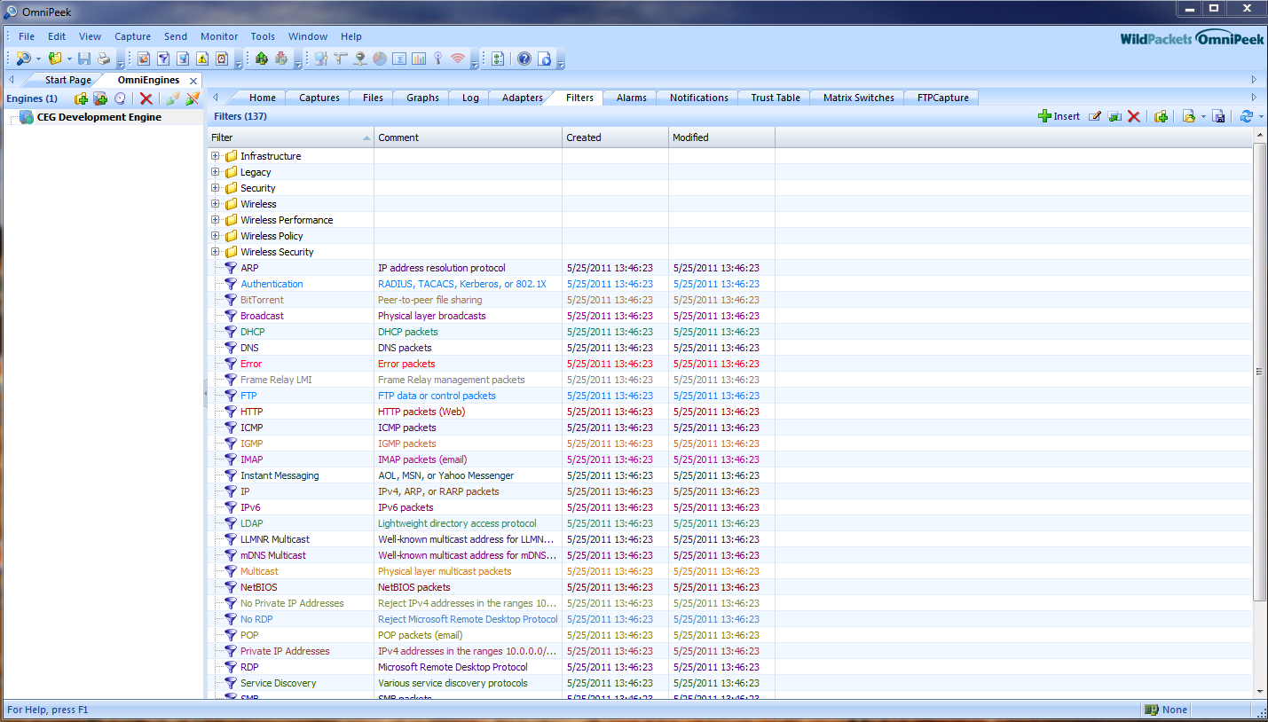
The second way is when creating a new capture to select the Filters tab from the Capture Options dialog:
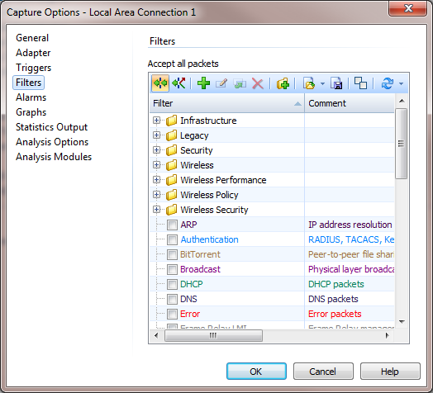

In either case one next either clicks on the green arrow icon (“Insert”) or right clicks on the window and chooses “Insert”.

An Insert Filter dialog comes up:
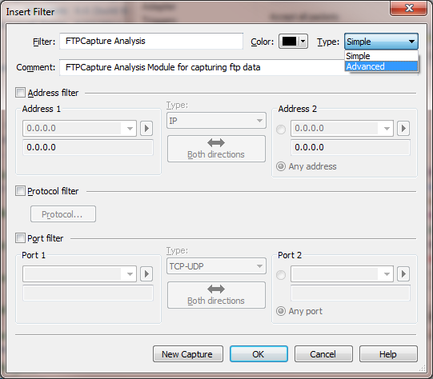
Give a name to the filter as shown above, a comment (optional), and select “Advanced” as the filter type.

When “Advanced” is selected the window will change to reflect the advanced view as shown here:
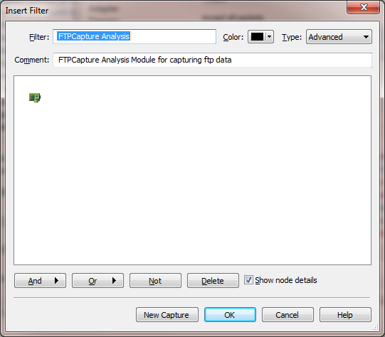
Select the “And” button (circled above).

An Analysis Module Filter dialog comes up. In this window select “FTPCapture” from the drop down list if it isn’t already selected.
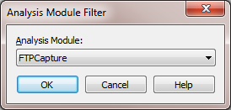
Press OK to select this filter and close the Analysis Module Filter dialog.

You will see your new filter displayed, and you can press OK to accept this filter:
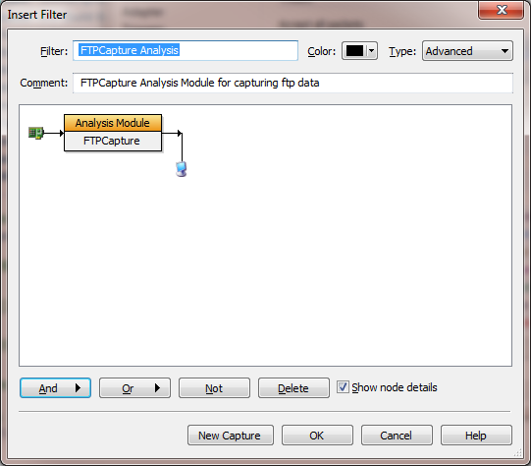

You will be returned to the Capture Options dialog or the Filters tab depending on which method you used. Note that you must press “Click here to send changes” in order for the action to have effect:
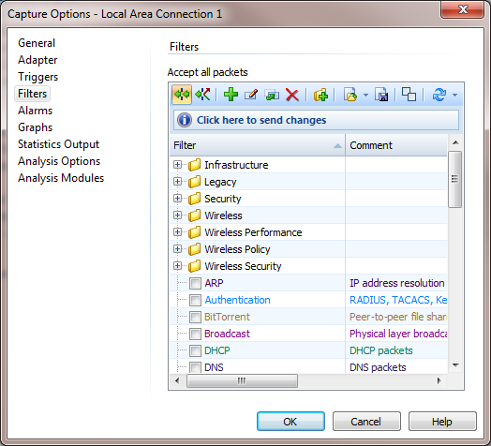
- OR -
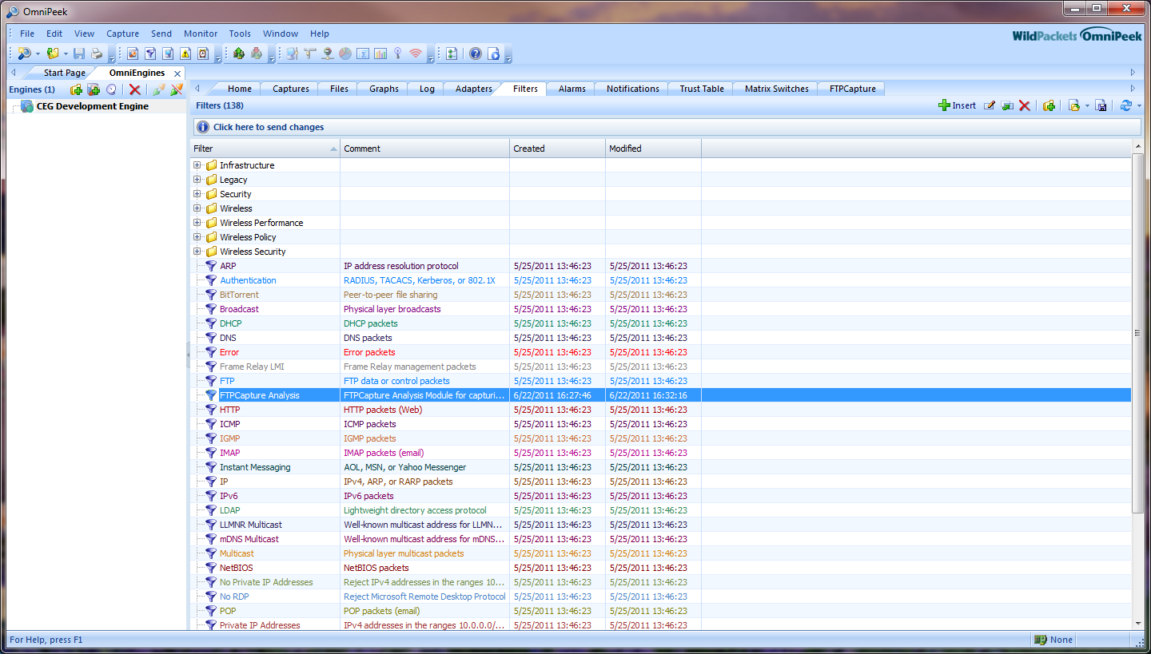

Selecting the FTPCapture Analysis Module When About To Run a Capture
Once the filter for FTPCapture has been created for any instance of OmniPeek then it will persist and need not be created again unless there is a significant change such as a new version of OmniPeek being installed. That said, every time a capture is run for which FTPCapture will be used, he filter must be selected.
Filter selection can be done in two ways. One is at the time of creating a new capture. From the Capture Options dialog select the Filters tab and check the box for FTPCapture Analysis (whatever it has been named when created):
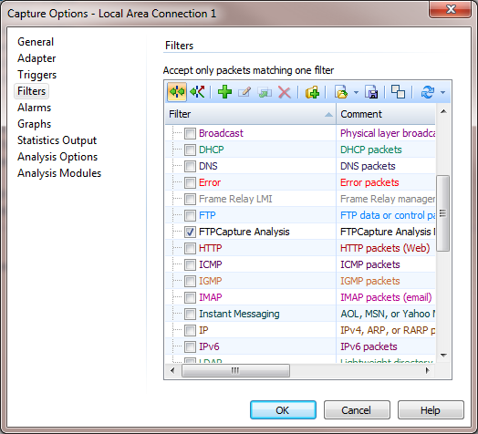

The other way to select the filter is from the capture window itself. From here click on the Filters tab and check the box next to the FTPCapture Analysis entry. Note that if “Click here to send changes” appears you must click on this:
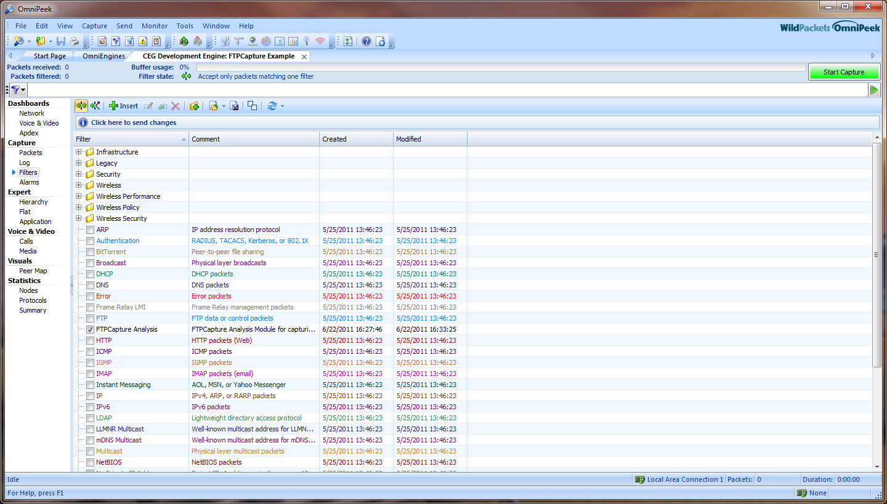

Setting Options for FTPCapture
Options are set from the Capture Options dialog. They can be set when starting a new capture and they can also be changed from this dialog during an existing capture session. Note that the settings are persisted from one session to the next but that they are persisted locally on OmniPeek. Thus if a new capture is started on a remote engine from an instance of OmniPeek that is different from the OmniPeek instance that a prior capture was started from, the options will need to be re-established on the newer instance of OmniPeek.

From the Capture Options dialog select the Analysis Modules tab and select FTPCapture as the analysis module (note that multiple analysis modules may well be displayed although in the example below only FTPCapture is shown):
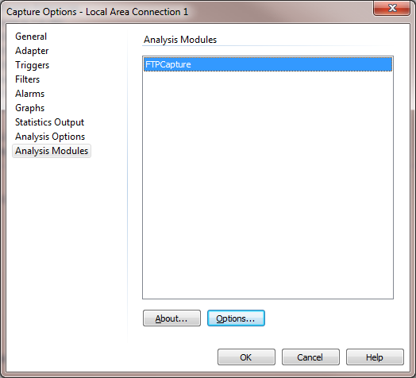
Now either double click on the FTPCapture entry or press the Options button.

The FTP Capture Options dialog will be displayed. This dialog has three tabs: “Target Names”, “Ports” , and “Logging and Alerting”.

Note that in the New Functionality build there will be a fourth tab. This is described in the New Functionality section later in the document.

The Target Names Tab

Below is the FTP Capture Options dialog as it comes up. The Target Names tab is displayed:
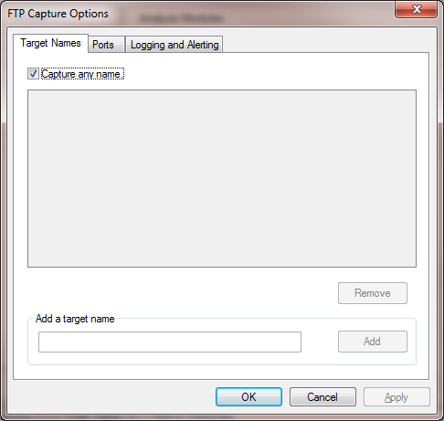

By default the Target Names tab will be as displayed as above with “Capture any name” selected. This means that ftp data for any ftp user will be processed by the plugin. If this is the case for the session that is being configured then no further action on this tab is necessary.

If “Capture any name” is unchecked then the controls for adding specific target names will become enabled. To add a target (i.e. an ftp user name) enter the user name into the edit box under the “Add a target name” heading and press the Add button. Any number of target names may be added.

By selecting a name and pressing the Remove button the target name will be deleted from the list.

In the example below three names have been added. Note that by default each will be displayed as selected when added. By unchecking any name for a given capture the associated target name will not be active for the capture.
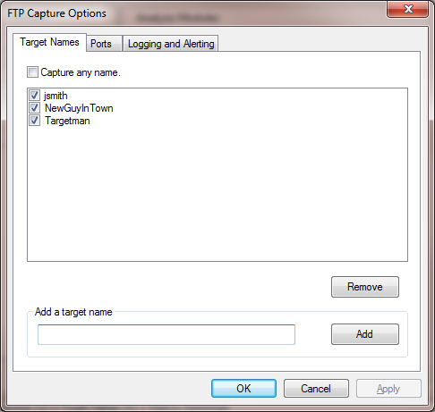

Below we see that NewGuyInTown has been deselected and Targetman has been removed. This means that only jsmith will be an active target for the capture.
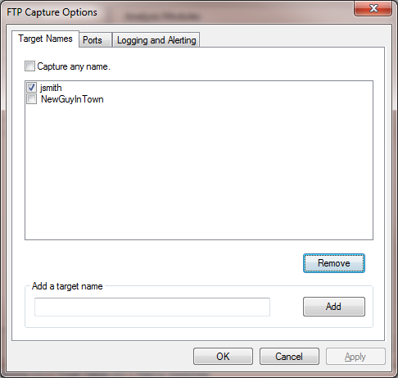

The Ports Tab
On the Ports tab you will find that port 21 is enabled by default.
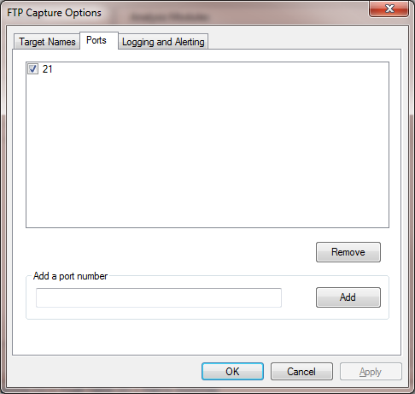
Port 21 should be all you need, but the capability exists for port numbers to be added just as names were added on the Target Names tab.

The Logging and Alerting tab
The Logging and Alerting tab is initialized by default as displayed below:
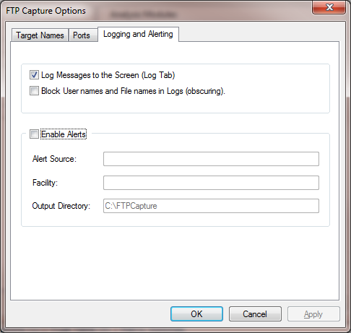

The various selection possibilities are explained in the following sections, with example results shown.
Log Messages to the Screen (Log Tab)
This option will cause relevant messages regarding the ftp capture results to be listed on the capture window’s log tab. Here is a sample result for a target name of “user1”:
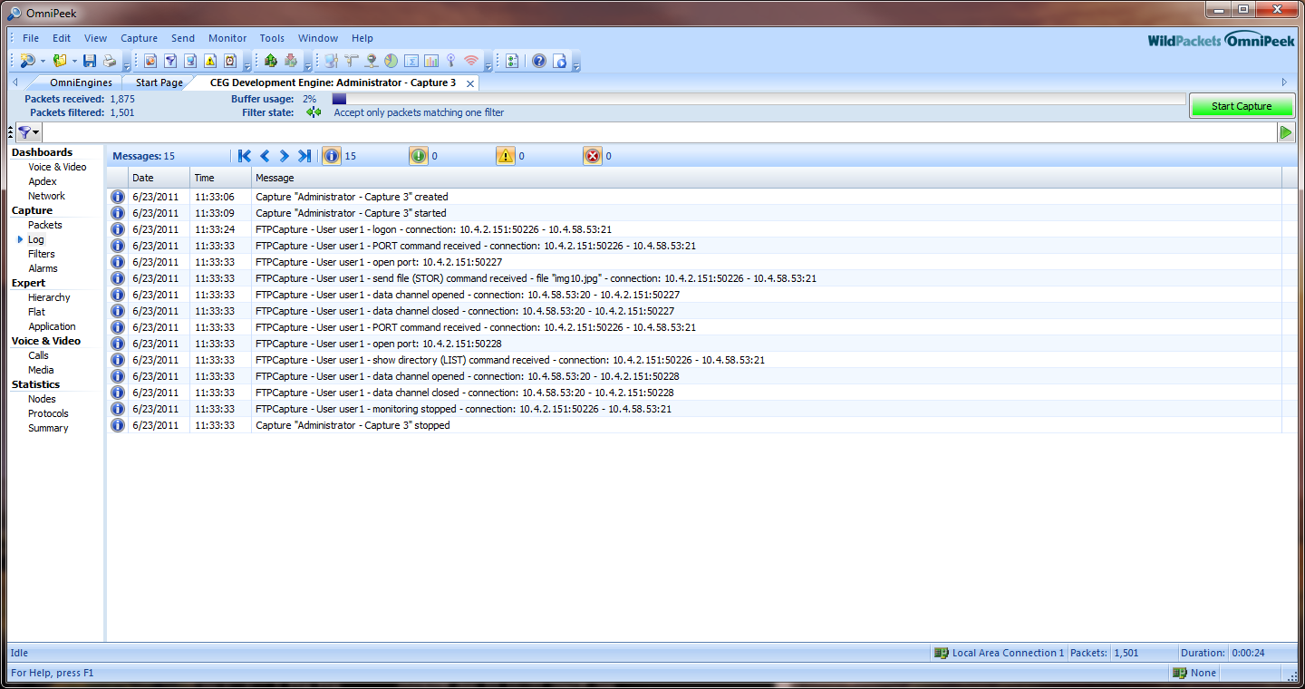

Block user names and file names (obscuring)
This will cause user names and file names to be replaced with asterisks. The above sample capture would look like the following if this selection were made:
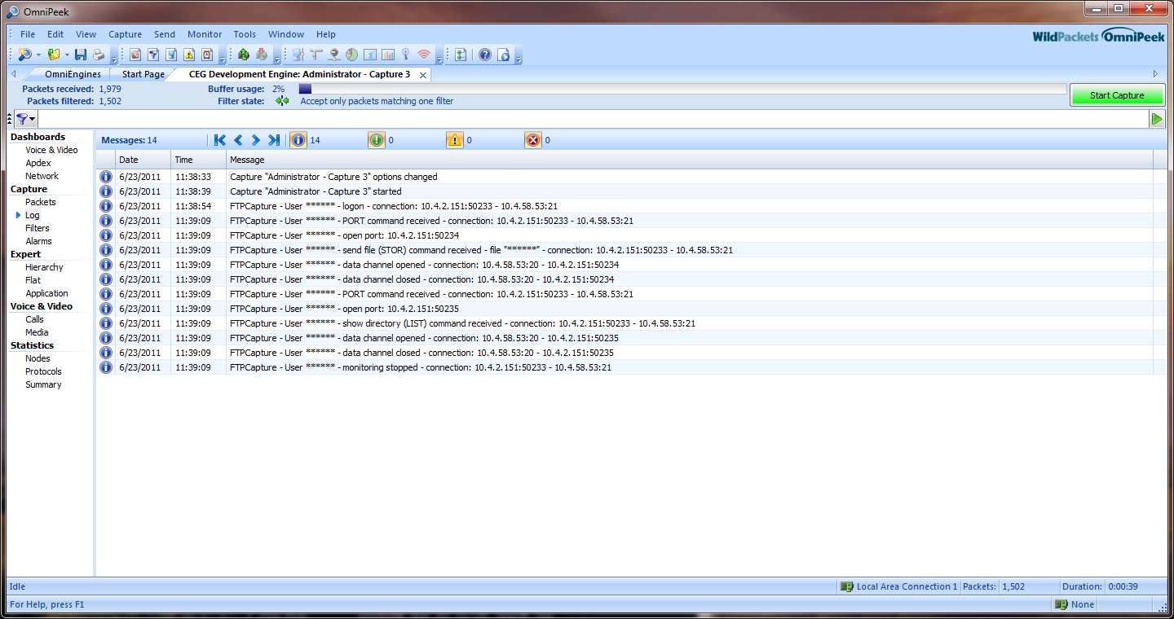

Enable Alerts
Enable Alerts is a specialized function that may not normally apply. If the Enable Alerts box is checked then three edit boxes are enabled. You should select this only if you are knowledgeable about the option.

Below is a sample entry followed by the results:
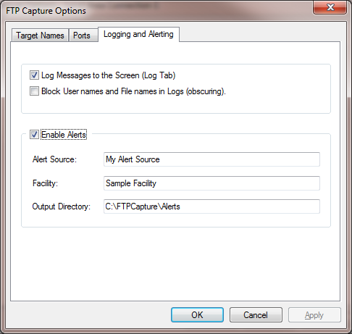

The above entry will cause files to be written to the specified output directory on the OmniEngine server as ftp captures proceed. Each file will have an unique file name that is formatted with the Facility name, a time string and the suffix “rtnalert”. Here is an example file name for the above configuration:
Sample Facility 2011-06-23T21.17.02.184Z.rtnalert

The file is really of the xml type. Below some example contents for this file are shown:

<?xml version="1.0" encoding="utf-8" ?>
- <Alert xmlns="http://tempuri.org/RTNAlert.xsd">
<Source>My Alert Source</Source>
<AlertDateTime>2011-06-23T21.17.14.446Z</AlertDateTime>
<FacilityName>Sample Facility</FacilityName>
<IPAddress>10.4.2.151</IPAddress>
- <Variables>
<Variable key="FTPCommand">RETR</Variable>
<Variable key="FTPUser">User user1 -</Variable>
<Variable key="FTPFilename">User user1 -</Variable>
<Variable key="ClientIP">10.4.2.151</Variable>
<Variable key="ClientPort">50939</Variable>
<Variable key="ServerIP">10.4.58.53</Variable>
<Variable key="ServerPort">21</Variable>
</Variables>
</Alert>

FTPCapture Summary Statistics
The Summary tab under Statistics on the tabs pane will have a listing for FTPCapture as shown below:

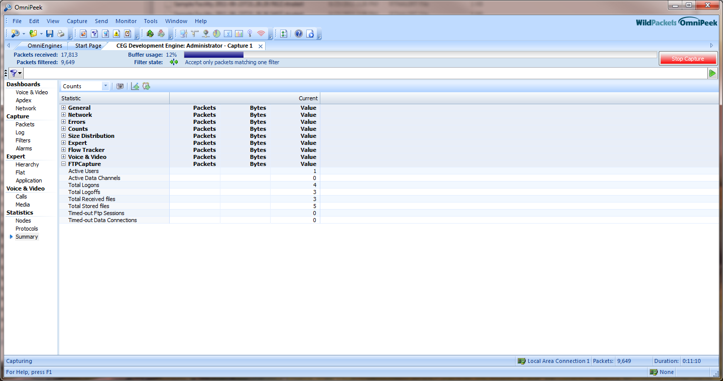

Eight items are listed, these being the following (note that totals are for the capture since it was started):
- Active Users – the number of user ftp sessions (i.e. ftp channels or “connections”) currently being actively monitored by the plugin. Each connection equates to a user session.
- Active Data Channels – noting that in addition to the ftp channel there is a correlate data channel (connection), this statistic displays the number of active data channels.
- Total Logons – the total number of successful ftp sessions created (via a valid logon transaction or by acceptance of an Anonymous user request).
- Total Logoffs – the total number of ftp sessions that terminated normally.
- Total Received files – the total number of “gets”, i.e. files transferred from server to client.
- Total Stored files – the total number of “puts”, i.e. files transferred from client to server.
- Timed-out Ftp Sessions – the total number of sessions that were not terminated normally and timed out after 5 minutes*.
- Timed-out Data Connections – the total number of data connections that were not terminated normally and timed out after 5 minutes*.

*The plugin has an internal monitor service that cleans up ftp sessions and data connections that were not terminated normally. The timeout period is set for five minutes.

Running A Capture
To start an FTPCapture capture session that has been configured, simply press the green “Start Capture” button (which changes to a red “Stop Capture” button when the capture is active). Below is a sample screen print of an FTPCapture session in progress:

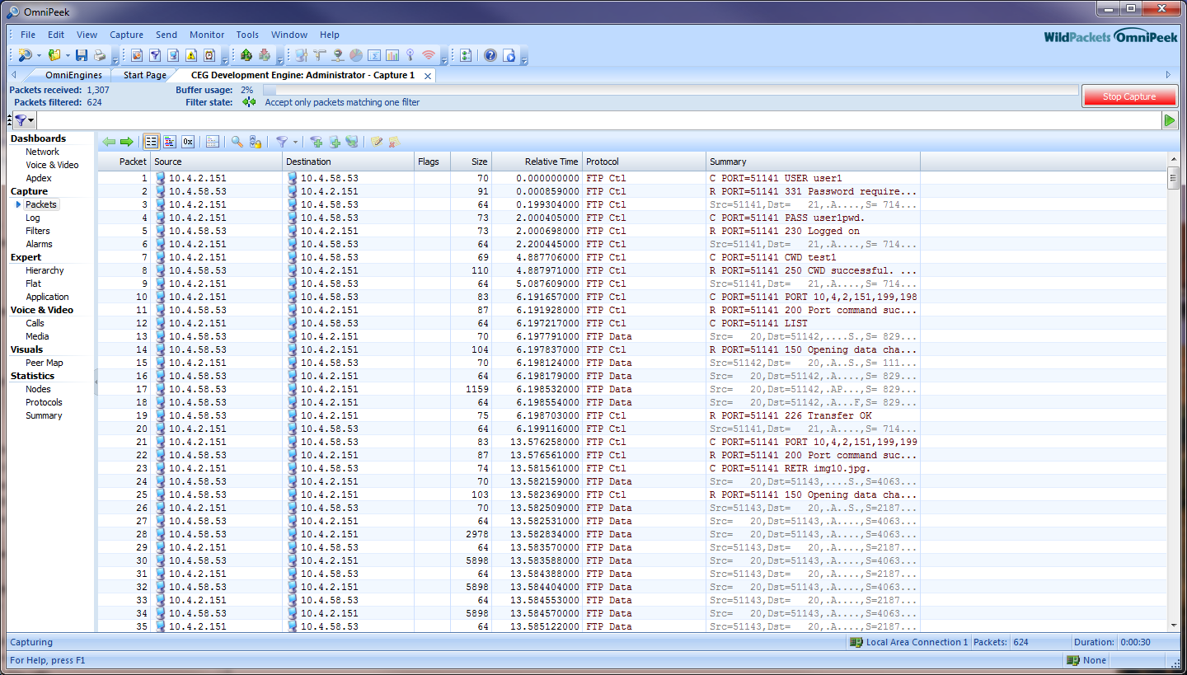

Note that since this is an engine capture it is not necessary to leave OmniPeek running during the capture. The capture can be left running when OmniPeek closes, and can be connected to from any OmniPeek instance.

New Functionality
Currently there is a set of new features that have been added to the FTP engine plugin but which do not exist in the console plugin version. These are controlled by a compile option and allow creation of a separate executable (FTPCapture.dll) that includes the new functionality. This new functionality is represented by a new options tab. The functionality and the new tab will now be described.

New Options Tab: “Data Transfer”
Below is a screen print of the new Data Transfer tab that has been added to the Options dialog in the new functionality plugin build.

Below is the Options dialog with the Data Transfer tab selected:
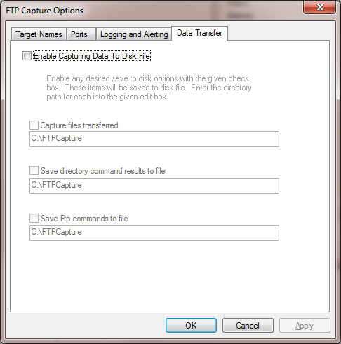

Note that the new functionality represented by this tab is not active by default. Clicking on “Enable Capturing Data To Disk File” enables the tab and allows selecting from one to three new functionality items.

Below is an example configuration for this tab:
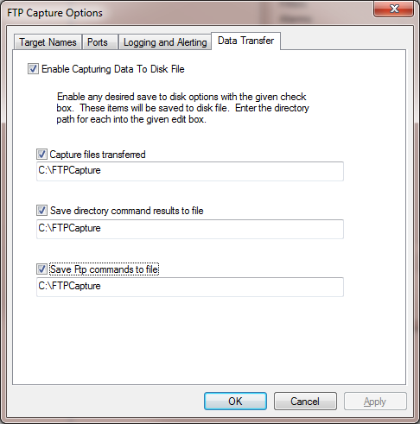
In the example above the default directory of C:\FTPCapture was not changed. This means that all results (as explained below) will all go to this same directory. It is possible with the three edit boxes to specify having a separate directory on the OmniEngine for each result set.

The three options are described below.

Capture files transferred
If “Capture files transferred” is selected then any files transferred via an ftp session for a configured user will be captured into the directory on the OmniEngine specified in the corresponding edit box. The result file name will be created as follows:
<target name>_<unique timestamp string>_<original file name>
Here is an example file name for a capture of the transferred file img10.jpg:
user1_2011-06-23T22.28.40.979Z_img10.jpg

Save directory command results to file
With ftp, directory queries are sent over the same data channel that is used for sending files. If “Save directory command results to file” is selected then these directory queries will be capture to a disk file. The file name will be constructed as follows:
<target name>_<unique timestamp string>_FtpDirectory.txt
Below are example contents of this text file:

Directory text for user user1 on connection 10.4.58.53:20 - 10.4.2.151:51183

-rw-r--r-- 1 ftp ftp 158910631 Jun 03 12:13 bigfile.mp4
-rw-r--r-- 1 ftp ftp 4811 Jun 07 08:02 Def Cap Template.xml
-rw-r--r-- 1 ftp ftp 1025859 Jun 07 08:03 Double Rainbow.JPG
-rw-r--r-- 1 ftp ftp 10387 Jun 01 16:23 ext_gstate_demo.pdf
-rw-r--r-- 1 ftp ftp 330579 Jun 01 16:20 filters.xml
-rw-r--r-- 1 ftp ftp 743 Jun 02 08:02 FunctionTest.txt
-rw-r--r-- 1 ftp ftp 1524390 Jun 23 11:39 img10.jpg
-rw-r--r-- 1 ftp ftp 10238 Jun 07 08:02 New Dev Work.docx
-rw-r--r-- 1 ftp ftp 422875 Jun 07 08:03 Open_Schedule_2010_-_2011.pdf
-rw-r--r-- 1 ftp ftp 277 Jun 06 16:37 Songs.txt
-rw-r--r-- 1 ftp ftp 8482687 Jun 07 15:20 Spectrum Expert Users Guide.pdf
-rw-r--r-- 1 ftp ftp 158910631 Jun 03 12:14 St_Francis_April_2011_Concert.mp4
-rw-r--r-- 1 ftp ftp 29759 Jun 03 11:58 TQE_EA.pdf
-rw-r--r-- 1 ftp ftp 13245 Jun 03 11:58 Withhold Status.xlsx
-rwxr-xr-x 1 ftp ftp 1524905 Jun 07 08:03 XLightSetup.exe

Save FTP Commands to File
The third new functionality item specifies that all client requests and server responses for a session be captured to file. The file name is constructed as follows:
<target name>_<unique timestamp string>_FtpLog.txt

Below are example contents of this text file:

Logging for user user1 on connection 10.4.2.151:51181 - 10.4.58.53:21

CWD test1
250 CWD successful. "/test1" is current directory.
PORT 10,4,2,151,199,238
200 Port command successful
RETR img10.jpg
150 Opening data channel for file transfer.
226 Transfer OK
PORT 10,4,2,151,199,239
200 Port command successful
LIST
150 Opening data channel for directory list.
226 Transfer OK
CWD ..
250 CWD successful. "/" is current directory.
PORT 10,4,2,151,199,240
200 Port command successful
LIST
150 Opening data channel for directory list.
226 Transfer OK

New Functionality on the Logging and Alerting tab
With the new functionality build there is one check box added to the Logging and Alerting tab. This is the “Show Password in Log” check box item. The extra item is unchecked by default. If checked this will cause the users logon password to be displayed in log messages and log files. The entry will be in the format
“User name @ Password”.

Below is a sample Log tab and sample text from an FtpLog.txt file that show the password in clear text:
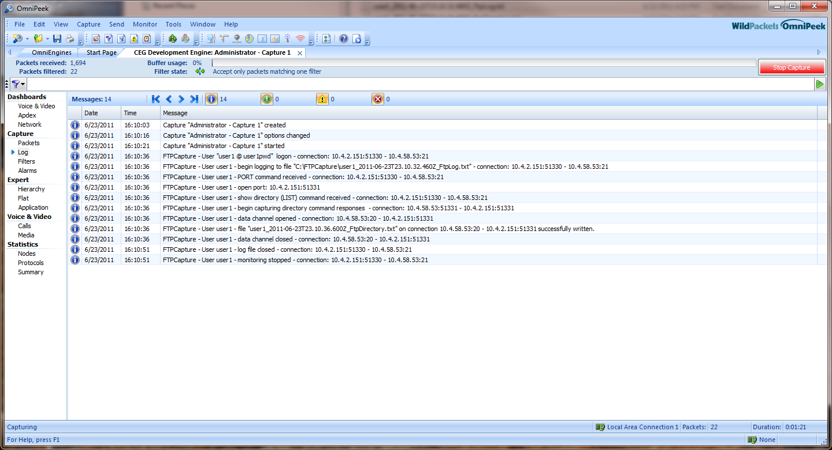

Logging for user "user1 @ user1pwd" on connection 10.4.2.151:51330 - 10.4.58.53:21

CWD test3
250 CWD successful. "/test3" is current directory.
PORT 10,4,2,151,200,131
200 Port command successful
LIST
150 Opening data channel for directory list.
226 Transfer OK

Impact of the Logging and Alerting Tab on the Data Transfer Tab
In the new functionality build there is one possible impact on new data transfer functionality of a selection on the Alerting Tab. If “Block user names and file names (obscuring)” is selected on the Alerting tab this will disable the Data Transfer tab. In other words, if the display of user names is disallowed then no data capture to file via the Data Transfer tab will be possible. If the “Block user names and file names (obscuring)” check box is re-enabled after having been disabled, the Data Transfer tab will also need to be re-enabled in order for it to have effect.

The FTPCapture View Tab
On the OmniEngines tab in the OmniPeek window for a connection to an OmniEngine there will be an FTPCapture tab as circled below:

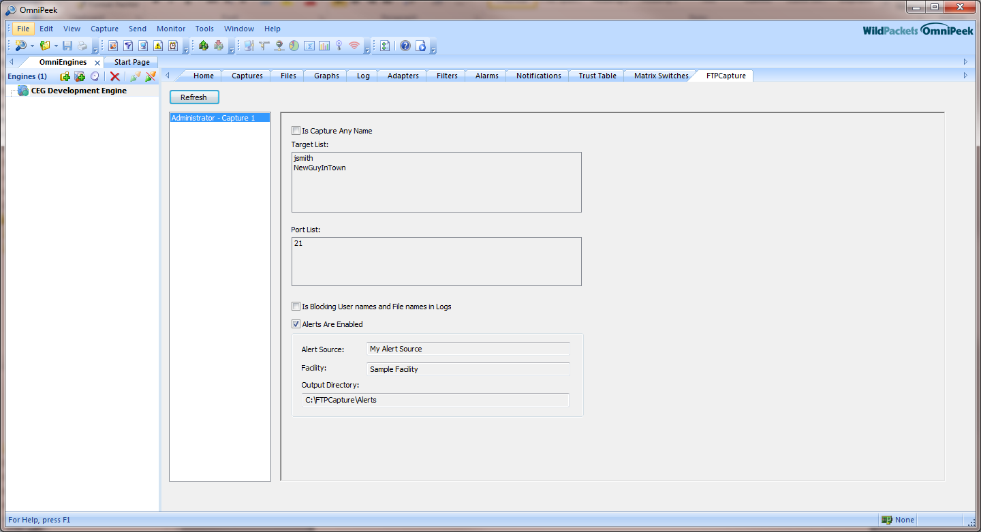

This display is view only and does not allow changing any options. It does, however, conveniently display the options that are current for a capture session. Note that user names or ports that are not selected in the options dialog will not appear here. Also, currently new functionality options are not displayed on the view tab.

